
RETAIL DEMO DISC PROGRAM REQUIREMENTS
By Millie Steury, David Rees and Michel Bastien

PROGRAM OVERVIEW
Thank you for your interest in the Xbox™ video game system Retail Interactive Demo Disc Program. By participating in this opportunity, you will have marketing concentration at over 10,000 stores in some of the top retailers, including:
- Wal-Mart
- Target
- Toys “R” Us
- Electronics Boutique
- GameStop

Our main objectives with the retail demo disc program are:
- Generate sales and increase attach rates.
- Showcase Xbox games technology.
- Educate and inform RSPs and consumers.

The demo disc will be updated at retail every other month using two different methods:
- Xbox Field Reps. The demo disc will be updated and installed by the reps at their serviced store locations.

- Direct-to-Store Mailings. The demo disc will be sent directly to non-serviced and some specific account locations for the RSPs to update.

Playable game demos not only give consumers an opportunity to play the game firsthand, but they also work as an invaluable marketing and PR tool. To that end, playable and non-playable demos should be an integral part of any marketing/PR plan.

When a playable demo is not available, there is simply no better way to generate hype than through the use of non-playable demos. Screenshots simply can’t do a game justice, particularly when it comes to portraying the incredible visual and aural experiences made possible by Xbox. Non-playable demos are a perfect way to showcase levels the playable demos won’t cover, build consumer awareness, and stir up some excitement over your upcoming title.

It is vitally important that publishers make developers aware of the need for a demo as early in the development process as possible. Publishers should make sure developers understand that a demo disc will ultimately bring better sales figures, and subsequently, more developer royalties.

By preparing demos, movies, and so on to coincide with editorial coverage and ad campaigns, you can make a huge impression on gamers and really show them what your game is all about.

CREATING A PLAYABLE DEMO

1. PRESENTATION AND USABILITY REQUIREMENTS
The Presentation and Usability Requirements define how the demo should unveil, step by step, as well as how the user should interact with it.

1.1 PRESENTATION FLOW CHART
The following chart summarizes the flow between the states of the game demo:

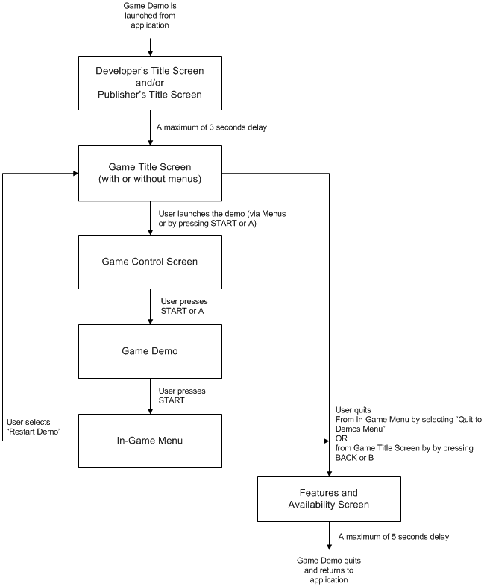

1.1.1 LAUNCHING THE INTERACTIVE DEMO

DEVELOPER/PUBLISHER TITLE SCREENS
This screen should contain the logo of the Developer and/or the Publisher. It’s the first thing to be shown. It should stay on the screen for no longer than three seconds.

GAME TITLE SCREEN
The Game Title Screen is the main menu of the game. If the game demo doesn’t feature menus, the Game Title Screen should read “Press START to begin” and “Press BACK to exit.” If the game demo does feature menus (limited or detailed), they should be displayed and should contain an option that can be selected to quit.

GAME CONTROL SCREEN
A Game Control Screen is an image of the Xbox Controller with instructions about how to play the game. It should appear when the user starts the demo. This image should clearly read “Press START to continue” and should remain on the screen until the user presses START or A. At that point, the user plays the demo.

1.1.2 IN-GAME MENU
While the user is playing the demo, if START is pressed, an In-Game Menu should appear. The following three options should be provided (with any other options that your demo must provide):
- “View Game Controls”
This option should bring up the Control Screen.

- “Restart Demo”
This option returns the user to the Game Title Screen.

- “Quit to Demos Menu”
This option quits the Interactive Demo.

1.1.3 QUITTING THE INTERACTIVE DEMO
Publishers may create an ending screen that states when the final game will be available, contains a list of features in the final game, gives hints, and/or displays any other marketing messages to the player that are pertinent to the demo or final game. From this screen, users will be returned to the Official Xbox Magazine Game Disc interface after a period of time no longer than five seconds.

2. TECHNICAL GUIDELINES
The technical guidelines for Xbox interactive demos are detailed in the document “Xbox Demo Technical Guidelines,” which is available on the Xbox Developer Support Web site. The major benefit of following these guidelines is that it guarantees that the interactive demo will work equally well in any of a number of situations.

3. CONTENT SUGGESTIONS
Suggestions to help in the preparation of the Interactive Demo.

3.1 GENERAL SUGGESTIONS

- The Interactive Demo should provide approximately 15 minutes of original gameplay. Xbox defines original gameplay as the time it takes to get familiar with the controls and complete the objectives of the demo.
- The playable demo should feature moderately challenging gameplay. The experience will be more enjoyable if the user doesn’t run into problems they can’t solve or into situations they can hardly overcome.
- The game demo may use more than one game control screen. If this is the case, the screens should simply be displayed one after the other.
- If the game features some cinematic sequences for introduction, they can be presented either before the initial Game Title Screen appears or right after the game demo is launched. It should be possible to interrupt these sequences by pressing either START or A.

3.2 DEMO CONTENT SUGGESTIONS
The developer is responsible for the content of the demo. Following are some general questions and ideas to help the developer choose the content of the demo, depending on the genre of the game.

GENERAL
- What are the features that are unique to your game? How can you emphasize some of these features in a game demo?
- Is there a gameplay element you should insist on?

ROLE PLAYING GAME / STORY DRIVEN GAMES
- How much of the storyline do you have to reveal to catch the interest of the player?
- Does it make sense to use cinematic sequences to introduce the context of the game and the character?
- What do you want the player to accomplish? Is there a simple objective that can be aimed for so that the user gets a glimpse of the combat system, different attacks and spells, and different creatures?

RACING GAMES
- What are the strong points of your racer? Is it how realistic it is? Is it how fast or how arcade-like it is? Is it the splendid environment of the tracks? How can you highlight this and make it stand out from other similar racers?

ACTION / FIRST PERSON SHOOTER
- What actions are unique to your game? Can the character swim, fly, or jump?
- Does your game feature any innovative weapon or fighting system? What’s the best way to let the player experiment with those?

SPORTS GAMES
- How does your game improve on the other sports titles out there? For example, how is your hockey game different from all the other ones? Is it because of its advanced AI or because of its incredible level of realism?

FIGHTING GAMES
- How do combos / special moves / counters work in your game? And how can you show the player how to execute these actions?
- What original characters should you show in a demo?
- What should be the location of the fight? Should it display some exceptional graphical feature of the game engine?

CREATING A NON-PLAYABLE DEMO

PRESENTATION
Non-playable demos are typically 45 second videos used to generate hype before a playable demo can be published. Traditional Hollywood movie trailers are great examples of the style, quality, and overall presentation.

Non-playable demos should include a single title screen with the name of the publisher or game, footage of actual gameplay, and footage of intros and/or cut-scenes. Ideally the preview trailer should not only get the viewer excited about the way a game looks and sounds, but also hint at its underlying story or premise.

RECOMMENDED ELEMENTS

- Title screen (game name, publisher, developer).
- ESRB rating of the final game (if one does not exist, “Rating Pending” should be displayed).
- At least 30 seconds of actual in-game play.
- High production value, similar to Hollywood movie trailers.
- Rendered intro sequences and cut scenes (to help convey story).
- Narration is recommended to add impact.
- Text can be used to help convey features or story elements.

LENGTH
Ideal running time is approximately 45 seconds. Non-playable demos should not exceed one minute, but exceptions can be made – please contact us in advance if you wish to provide a longer sequence.

ENDING A NON-PLAYABLE DEMO
Publishers may consider displaying a single ending screen that states when the final game will be available, contains a list of features in the final game, gives hints, and/or displays any other messages to the player pertinent to the game being previewed. From this screen, users should be returned to the interface. This screen should be displayed no longer than five seconds.

PLAYABLE DEMO SUBMISSION PROCEDURE

PROCESS

- The first step is to submit your demo to Microsoft for certification. All playable demos must pass through the Xbox certification process before they are approved for publication. This process is very similar to full-game certification and is controlled entirely by Microsoft. It requires filling out a certification form and and delivering your demo to the certification team on appropriate media. Demo certification is done on a first come first served basis and can take anywhere from 7 to 14 days. Please account for this duration in your schedule, as demos that do not make it through certification in time will NOT make the targeted disc. Contact your Xbox Account Manager for schedule details.

- All playable demos must be certified prior to the noted “CONTENT DELIVERED” scheduled deadline. Please contact your account manager to make arrangements.
- All demos must be submitted in full accordance with the requirements set forth in the Xbox Guide.
- All demos must be submitted with a launcher utility which launches the demo and passes it data in the same manner as described in the technical guidelines. The Xdemos launcher is provided on the Xbox Developer Support Web site for use in testing and submitting demos.

- Playable demos can be submitted to:
Xbox Certification Group
Attention: Debby Engevik
18500 Union Hill Road
Redmond, WA 98052

- In addition to Microsoft’s certification form, you must fill out a Retail Interactive Demo Disc Submission Form, which can be found at the end of this document. Please include a submission form with all playable demos to ensure proper processing.

SCHEDULE

RETAIL DEMO DISC
# | DISC | YR | CONCEPT SUBMISSION | CONTENT DELIVERED | BEGIN INSTALL
1.0 | Pre-Launch | 2001 | DONE | 09/04/01 | 09/20/01
1.1 | Launch | 2001 | ASAP | 10/10/01 | 11/01/01
1.2 | February | 2002 | 10/19/01 | 12/21/01 | 02/04/02
1.3 | April | 2002 | 12/21/01 | 02/15/02 | 04/01/02
1.4 | June | 2002 | 02/15/02 | 04/12/02 | 06/03/02
2.0 | August | 2002 | 04/12/02 | 06/14/02 | 08/05/02
2.1 | October | 2002 | 06/14/02 | 08/16/02 | 10/07/02
2.2 | November | 2002 | 08/16/02 | 09/13/02 | 11/04/02
2.3 | December | 2002 | 09/13/02 | 10/11/02 | 12/02/02

CERTIFICATION REQUIREMENTS
The game developer and publisher must fully understand the technical certification requirements for an Xbox game demo. Contact your Xbox account manager to receive an update to the TCR document. The Xbox Guide can be found online at http://xds.xbox.com, the Xbox support Web site for publishers and developers. Access to this Web site can be obtained through your account manager. If you do not know how to contact your account manager, please send e-mail to xbox@xbox.com.

The demos will be certified based on the full game TCR with additional restrictions placed. A general overview of the restrictions is as follows:

- No title persistent data area access
- No user data area access
- No alternate title data access
- No networking functionalities
- No memory unit access
- No nickname access
- No player-created game soundtrack access
- Must be fully accessible using default controller
- SDTV 4:3 mode only

ACCEPTED SUBMISSION FORMATS
- All interactive demos submitted to Microsoft for certification must be provided on DLTape IV media following the same guidelines apply to a full game submission.

NON-PLAYABLE DEMO SUBMISSION PROCEDURE

PROCESS

- All non-playable demos should be submitted to your account manager no later than the date listed on the attached schedule. Please be sure to send one VHS formatted copy and one professional quality copy (DV, DigiBeta, BetaSP) to your account manager.

- Please include a Retail Interactive Demo Disc Submission Form (found at the end of this document) with all non-playable demos to ensure proper processing. This form must be filled out and submitted along with all other materials.

SCHEDULE

RETAIL DEMO DISC
# | DISC | YR | CONCEPT SUBMISSION | CONTENT DELIVERED | BEGIN INSTALL
1.0 | Pre-Launch | 2001 | DONE | 09/04/01 | 09/20/01
1.1 | Launch | 2001 | ASAP | 10/10/01 | 11/01/01
1.2 | February | 2002 | 10/19/01 | 12/21/01 | 02/04/02
1.3 | April | 2002 | 12/21/01 | 02/15/02 | 04/01/02
1.4 | June | 2002 | 02/15/02 | 04/12/02 | 06/03/02
2.0 | August | 2002 | 04/12/02 | 06/14/02 | 08/05/02
2.1 | October | 2002 | 06/14/02 | 08/16/02 | 10/07/02
2.2 | November | 2002 | 08/16/02 | 09/13/02 | 11/04/02
2.3 | December | 2002 | 09/13/02 | 10/11/02 | 12/02/02

SUBMISSION REQUIREMENTS

- Accepted dimensions: While the Xbox can support a wide array of resolutions, the Official Xbox Magazine Game Disc will display only standard NTSC output for video playback. This gives you the option of letterbox or standard 4:3 full-screen image size.
  - NTSC (4:3)
  - PAL (for European markets)
- Accepted submission formats: We strongly recommend that all materials be provided in digital format. DV or MiniDV formats are our first preference; however, Digi-Beta is also an excellent choice. While we do accept Beta-SP tapes, we recommend against this option as it does not always produce the level of quality we are shooting for. Each video trailer submission should contain two tapes: one VHS version for easy viewing and one professional quality version to be published. (See Submission of Materials for submission details.)
  - DV/MiniDV (preferred) and VHS
  - Digi-Beta (preferred) and VHS
  - Beta-SP and VHS
SIZE LIMITATIONS
The Xbox Retail Interactive Demo Disc is a DVD-9 (8.54-GB capacity) format DVD. The total amount of space available for demos, trailers, and other extra materials is 6.4 GB. Unless a special arrangement is made, please try to keep preview trailers under one minute in length.

OFFICIAL XBOX MAGAZINE GAME DISC CONTACTS
If you are interested in even greater exposure for your Xbox playable or non-playable demos, you may consider distribution on the Official Xbox Magazine Game Disc. For more information regarding this option, see the contact information below.

Dave Rees, DVD Editor, OFFICIAL XBOX MAGAZINE
Imagine Media
150 North Hill Drive
Brisbane, CA 94005
drees@imaginemedia.com p.415.468.4684 x2511

Mike Salmon, Editor in Chief, OFFICIAL XBOX MAGAZINE
Imagine Media
150 North Hill Drive
Brisbane, CA 94005
msalmon@imaginemedia.com p.415.468.4684 x2127

Karen Quilantang, U.S. Sales and Marketing, OFFICIAL XBOX MAGAZINE
Imagine Media
150 North Hill Drive
Brisbane, CA 94005
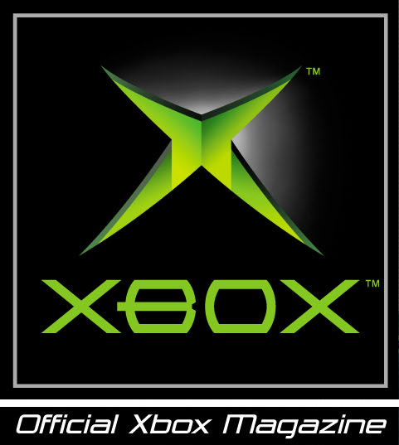karen@imaginemedia.com p.415.468.4684 x2172

RETAIL INTERACTIVE DEMO DISC SUBMISSION FORM

CONTACT NAME: DATE OF SUBMISSION:
TITLE:
EMAIL ADDRESS:
PHONE:
FAX:
PUBLISHER:
GAME TITLE:
INTENDED RELEASE DATE:
TYPE OF SUBMISSION: PLAYABLE DEMO NON-PLAYABLE DEMO

PLAYABLE DEMO DETAILS
DESCRIPTION OF DEMO:
SIZE OF DEMO (in MB):
NUMBER OF PLAYERS:
PERIPHERALS SUPPORTED:
DESCRIPTION OF ADDITIONAL MATERIALS (Artwork, Screenshots, etc.):

NON-PLAYABLE DEMO DETAILS
LENGTH: Mins: Seconds
MEDIA FORMAT: DV MDV Beta BetaSP DigiBeta SVHS VHS
DESCRIPTION OF ADDITIONAL MATERIALS (Artwork, Screenshots, etc.):

GENRE (check one):
Fighting
Simulation
Racing
Shooter
RPG
Sports
Action
Arcade
Puzzle
Graphic Adventure
Other (please specify)

ESRB RATING OF FINAL GAME (check one):
Early Childhood (EC)
Kids to Adults (KA)
Everyone (E)
Teen (T)
Mature (M)
Rating Pending (RP)
Descriptor Text:

SELECT DISC FOR THIS SUBMISSION (check one):
Pre-Launch
Launch
February
April
June
August
October
November
December

